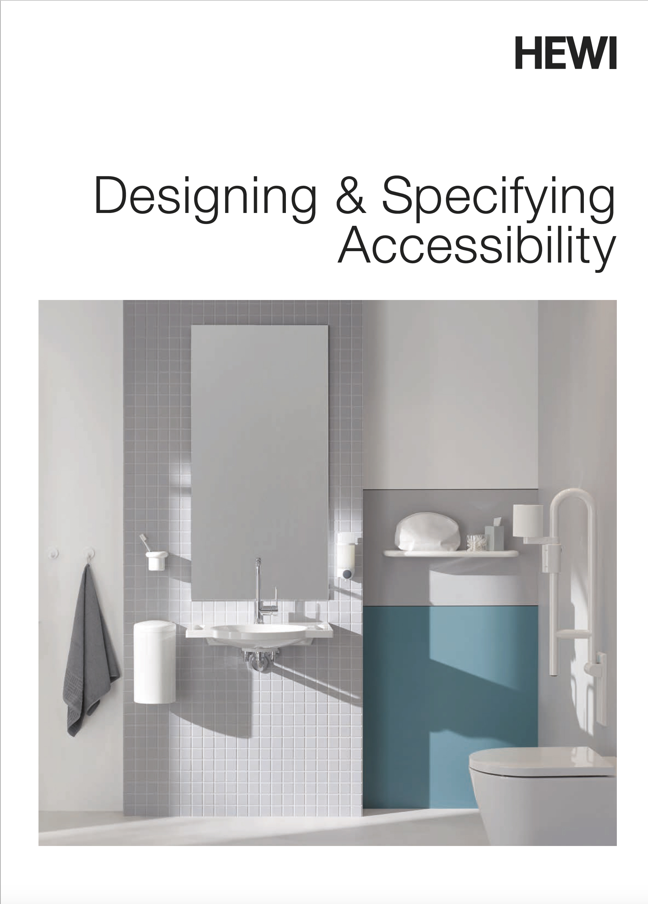102816 BATH ACCESSORIES 2018-04-02.1

SECTION 102816

BATH ACCESSORIES

**Specifier Note:** Editing notes for assisting users.

This guide specification section has word processing styles consistent with ARCOM Masterspec™ to facilitate integration with other specification sections. Text within square brackets **[example]** are options; text within angle brackets **<example>** indicate places where the Specifier is to insert text.

Measurements for imperial units (inch-pound) and metric units (SI) have special formatting to facilitate selection and deletion, or both can be used.

In the Part 2 product articles, there are line drawings to assist the editor in selecting appropriate units. These drawings are formatted as “Illustration” style to facilitate selection for removal, or they can be left in the final specification for convenience of the Owner and Contractor (recommended).

Specific sustainability documentation does not apply to the products in this section. However, HEWI's manufacturing process involves recycling of materials, yielding almost no waste. Because the surface finish of HEWI products is achieved without application of coatings and without sanding or buffing, a uniform appearance that is easily cleanable is achieved without procedures that negatively affect the environment.

HEWI manufactures all products in this section in Germany and/or the US. Häfele is a distributor of HEWI products in the United States and uses different product numbers. **This guide specification includes both HEWI numbers in black text and Häfele numbers, when available, in red text.** This specification section can be edited with either or both designations, depending on location.

Contact HEWI at [**hewi@hewi.us**](mailto:hewi@hewi.us) with questions.

1. GENERAL
   * + 1. SUMMARY
          1. Section Includes:

Grab bars.

Shower and bath seats.

Bathroom accessories.

* + - * 1. Related Requirements:

Section 061053 - Miscellaneous Rough Carpentry: Concealed wood blocking for support anchorage.

Section 092116 - Non-Structural Metal Framing: Concealed steel support anchorage components.

* + - 1. PREINSTALLATION MEETINGS
         1. Conduct pre-installation meeting at Project site before wall finishes are applied to stud framing.

Attendees: Owner, Architect, Contractor, bath accessory installer, and other installers for partitions and applied finishes.

Review installation requirements, including blocking to support bath accessories.

Verify installation locations, heights, and clearances.

* + - 1. ACTION SUBMITTALS
         1. Submittal Requirements: See Section 013300 - Submittal Procedures.
         2. Product Data: Submit data for each product.

Include tested live load capacities.

* + - * 1. Shop Drawings:

Show locations, mounting heights, and required clearances.

Show concealed supports, anchors and fasteners, and attachment details.

* + - * 1. Selection Samples: Coupons of available standard colors.
      1. INFORMATIONAL SUBMITTALS
         1. Submittal Requirements: See **[Section 017800 - Closeout Submittals] <insert section name and number>**.
         2. Quality Certificates:

Medical Device Certification per EN ISO 13485: Design and development, production and sales of barrier-free products as well as sanitary accessories with supporting therapeutic and physical effect.

ISO 50001: Development, production and distribution of signage, building hardware, grab rails and balustrades, sanitary accessories and barrier-free products as well as the development, production, surface finishing and distribution of plastic injection-molded products, as well as the necessary molds and production resources.

ISO 9001, 14001: Development, production and distribution of signage, building hardware, grab rails and balustrades, sanitary accessories and barrier-free products as well as the development, production, surface finishing and distribution of plastic injection-molded products, as well as the necessary molds and production resources.

* + - * 1. Manufacturer installation instructions.
      1. CLOSEOUT SUBMITTALS
         1. Submittal Requirements: See **[Section 017800 - Closeout Submittals] <insert section name and number>**.
         2. Operation and Maintenance Data: Annual adjustment, care, and cleaning instructions.
         3. Manufacturer warranties.
      2. MAINTENANCE MATERIAL SUBMITTALS
         1. Supply units in factory packaging and store in building where directed by **[Owner] [or] [Architect]**.

**<Enter accessory here>**: **<Enter quantity here>**

**<Enter accessory here>**: **<Enter quantity here>**

**<Enter accessory here>**: **<Enter quantity here>**

* + - 1. QUALITY ASSURANCE
         1. Installer Requirements: Experienced firm with skilled installation workers.
         2. Mock-ups: Install bath accessories in [**one**] [**one of each typical**] [**bathroom**] [**toilet room**] selected by Architect.
      2. DELIVERY, STORAGE, AND HANDLING
         1. Store products inside building in original packaging.
      3. WARRANTY

Specifier Note: Normal warranty period is 2 years. Longer special warranties are available from HEWI and Häfele on selected items. Contact your product representative or the manufacturer for further information on available warranties.

* + - * 1. Manufacturer Warranty: Warrant products against failure for period of 2 years. Failure includes delamination and cracking of finish under normal service conditions for products that were correctly installed.

1. PRODUCTS
   * + 1. MANUFACTURERS

Specifier Note: Not all the products offered by HEWI have Häfele equivalents. See product articles below.

* + - * 1. Basis of Design: Provide products by [**HEWI**] **[or]** [**Häfele**].

Substitutions: [**Not permitted.**] [**See Section 012500 - Substitution Procedures.**]

Specifier Note: Use Ctrl + mouse click to activate following hyperlinks.

HEWI Contact Information: <https://www.hewi.com/en/>

Häfele Contact Information: [www.hewi.com/en-us/contact/us-haefele/](http://www.hewi.com/en-us/contact/us-haefele/)

* + - 1. PERFORMANCE REQUIREMENTS

Specifier Note: ADA standards are not enforced by building officials. The International Building Code cites the ICC/ANSI A117.1 document, but some states have additional modifications that should be stated in the following paragraph as well as the ADA standards.

* + - * 1. Accessibility Requirements: Comply with applicable provisions in Department of Justice *2010 ADA Standards for Accessible Design* and [**ICC/ANSI A117.1**] **<insert applicable state accessibility requirements**>.
        2. Install units to support following total loads.

Stationary Grab Bars: **330 lbs (150 kg)**. except as noted.

Swing-Up Grab Bars: **220 lbs (100 kg)**.

Wall-Mounted Shower Seats: **450 lbs (200 kg).**

Freestanding Benches: **770 lbs (350 kg).**

* + - 1. MATERIALS

Specifier Note: Shower rods have aluminum cores, all other products have galvanized steel cores.

* + - * 1. Basic Construction: Galvanized steel core unless noted as aluminum with through-color, non-porous polyamide covering.

Grab Bars and Shower Seats: 4 mm thick through-color, nonporous polyamide covering.

Mounting Flanges: Galvanized steel with clip-on color polyamide rosettes.

Hinges: Stainless steel with color polyamide covering.

Specifier Note: If different colors for different areas are required, provide schedule on the drawings or at the end of Part 3 in this Section. Not all products are available in all colors.

Color: **[99 - Pure White] [or] [95 - Stone Gray] [or] [92 - Anthracite Gray] [or] [90 – jet black] [or] [86 - Sand] [or] [84 - Umber] [or] [33 – ruby red] [or] [Standard colors selected by Architect] [or] [As scheduled on Drawings] [or] [As scheduled in Part 3]**.

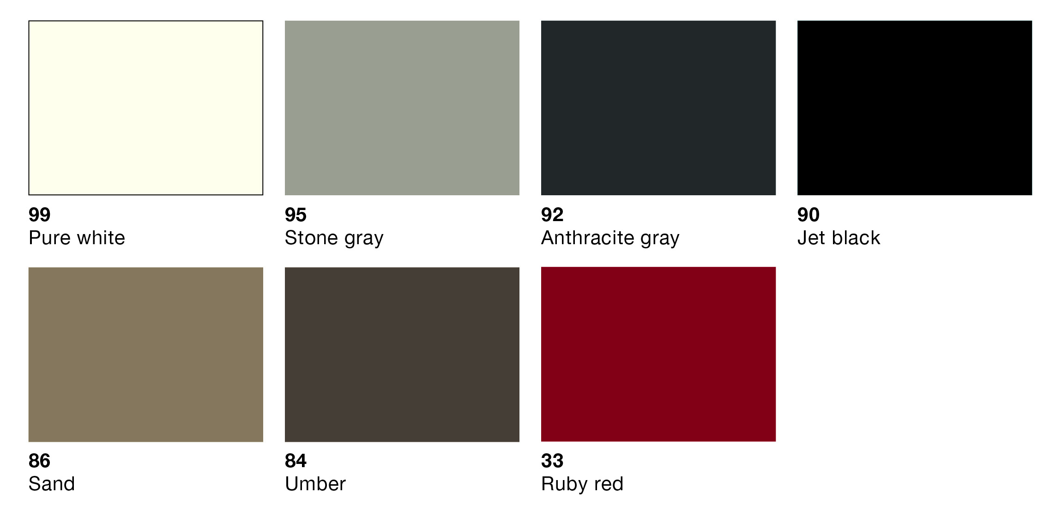

Specifier Note: In the following articles HEWI product numbers in black text are the first option, followed by the Häfele product numbers in red text. Not all HEWI products have Häfele equivalents. Häfele product numbers end with .xx and can be replaced with the following 2-digit color designations:

33 Ruby red

84 Umber

86 Sand

90 Jet black

92 Anthracite gray

95 Stone gray

99 Pure white

Specifier Note: HEWI product numbers use the same color codes appended as a decimal suffix. In both instances color can be specified as indicated above instead of additionally identifying color on each type of unit.

* + - * 1. Anchorages: Tamper-resistant.
      1. STATIONARY GRAB BARS
         1. General: **330 lb (150 kg)** live load capacity, ADA-compliant design.

Except as noted

* + - * 1. Straight Grab Bars: Two anchorage supports.

Length: **12 inches (305 mm)** c/c **[801.36US100] [or] [988.61.0xx].**

Length: **16 inches (406 mm)** c/c **[801.36US110] [or] [988.58.0xx].**

Length: **18 inches (457mm)** c/c **[801.36US120] [or] [988.61.1xx].**

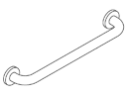

Specifier Note: The following units do not have equivalent Häfele models.

* + - * 1. Straight Grab Bars: Two anchorage supports. Load capacity **250 lbs (113 kg).**

Length: **18 inches (457mm)** c/c **[950.36US1190].**

Length: **24 inches (610 mm)** c/c **[950.36US1390].**

Length: **36 inches (914 mm)** c/c **[950.36US1490].**

Length: **42 inches (1067 mm)** c/c **[950.36US1590].**

C:\~$MpsTemp\S05197.tif

* + - * 1. Grab Bars: Two anchorage supports; **[suitable for supporting removable hanging seats except as noted]**.

Length: **24 inches (610 mm)** c/c **[801.36US130] [or] [988.61.2xx].**

Length: **30 inches (762 mm)** c/c **[801.36US140] [or] [988.61.3xx].**

Length: **36 inches (914 mm)** c/c **[801.36US150] [or] [988.61.4xx].**

Note: Live load capacity **250 lb** (**113 kg)** see Grab Bars with centered third anchorage to hang seats and ADA compliant

Length: **42 inches (1067 mm)** c/c **[801.36US160] [or] [988.61.5xx].**

Note: Live load capacity **250 lb** (**113 kg)** see Grab Bars with centered third anchorage to hang seats and ADA compliant

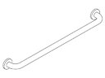

* + - * 1. Grab Bars: Center third anchorage support**; [suitable for supporting removable hanging seats]**.

Length: **36 inches (914 mm)** c/c **[801.36US200] [or] [988.62.1xx].**

Length: **42 inches (1067 mm)** c/c **[801.36US210] [or] [988.62.2xx].**

Length: **48 inches (1219 mm)** c/c **[801.36US220] [or] [988.62.3xx].**

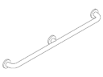

* + - * 1. Grab Bars for Toilet Compartments: Right-angle end, offset wall, and straight end supports.

Length: **48 inches (1219 mm)** center to wall **[801.36US300] [or] [988.82.4xx].**

Length: **52 inches (1321 mm)** center to wall **[801.36US310] [or] [988.82.5xx].**

Length: **54 inches (1372 mm)** center to wall **[801.36US320] [or] [988.82.6xx].**

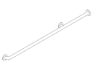

* + - * 1. L-Shaped Grab Bars: Vertical bar with two supports, short horizontal bar with one support; suitable for removable hanging seats.

Size: **24 inches (610 mm)** c/c vertical by **12 inches (305 mm)** c/c horizontal **[801.22US100] [or] [988.72.1xx]**.

Size: **36 inches (915 mm)** c/c vertical by **18 inches (457 mm)** c/c horizontal **[801.22US110] [or] [988.72.5xx]**.



* + - * 1. L-Shaped Corner Grab Bars: Horizontal bar with two supports on long leg, one end support on short leg; suitable for removable hanging seats.

Size: 37-1/2 inch (952 mm) center to wall **[801.35US100] [or] [988.65.1xx].**

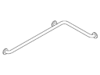

* + - * 1. Equal Leg Corner Grab Bars: Horizontal bar with two supports on each leg; suitable for removable hanging seats.

Size: **25-1/2 by 25-1/2 inches (647 by 647 mm)**; **[801.35US110] [or] [988.65.3xx]**.

Size: **37-1/2 by 37-1/2 inches (952 by 952 mm)**; **[801.35US120] [or] [988.65.5xx]**.

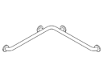

* + - * 1. Corner and Vertical Grab Bars: Corner grab bar with vertical leg; suitable for removable hanging seats.

Size: **31-1/2 by 31-1/2 inches (800 mm)** horizontal, **30 inches** **(762 mm)** vertical; **[801.35US200] [or] [988.68.1xx].**

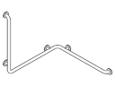

* + - * 1. Corner Grab Bars with Shower Head Holder: Corner grab bar with vertical leg and adjustable height shower head holder.

Size: **31-1/2 by 31-1/2 inches (800 mm)** horizontal, **49-3/16 inches** **(1250 mm)** vertical; **[801.35US220] [or] [988.68.1xx].**

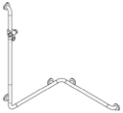

* + - * 1. Grab Bar with Shower Head Holder: Vertical bar with adjustable shower head holder.

Size: **24 inches (610 mm)**; **[801.33US100] [or] [988.66.7xx]**.

S03114

* + - * 1. L-Shaped Grab Bar with Shower Head Holder: Vertical bar has adjustable shower head holder.

Size: **36 inches (915 mm)** vertical, **18 inches (457 mm)** horizontal; **[801.33US200] [or] [988.67.3xx].**

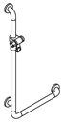

* + - 1. SWING UP GRAB BARS

Specifier Note: The following units do not have equivalent Häfele models.

* + - * 1. Swing-Up Grab Bar: Double bar that swings up and is held in vertical position by friction; **220 lb (100 kg)** load capacity.

Projection: **23-5/8 inches (600 mm)**; **[801.50US200]**.

Projection: **27-9/16 inches (700 mm)**; **[801.50US210]**.

Projection: **33-7/16 inches (850 mm)**; **[801.50US220].**

Projection: **35-7/16 inches (900 mm)**; **[801.50US230**].

Projection: **29-1/2 inches (750 mm)**; **[801.50US240]**.

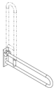

* + - * 1. Rotatable Swing-Up Grab Bar: Double bar that swings up and is held in vertical position by locking device; rotatable for storage parallel to wall; **220 lb (100 kg)** load capacity.

Projection: **23-5/8 inches (600 mm)**; **[801.50US100] [or] [988.91.6xx]**.

Projection: **27-9/16 inches (700 mm)**; **[801.50US110] [or] [988.91.7xx]**.

Projection: **33-7/16 inches (850 mm)**; **[801.50US120] [or] [988.79.3xx]**.

Projection: **35-7/16 inches (900 mm)**; **[801.50US130] [or] [988.91.8xx]**.

Specifier Note: The following unit does not have an equivalent Häfele model. Items are the same, but re-labled with Häfele product numbers.

Projection: **29-1/2 inches (750 mm)**; **[801.50US140]**.

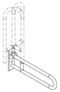

* + - 1. SHOWER SEATS AND BATH SEATS
         1. Wall-Mounted Rectangular Seats: ADA-compliant fold-up seat with drainage spaces between slats; **450 lb (204 kg)** load capacity; supplied with anchorage components for cavity walls.

Size: **15-1/16 by 21-7/8 inches (382 by 555 mm)**; **[801.51US440] [or] [980.20.0xx]**.

Size: **15-1/16 by 29-1/8 inches (382 by 739 mm)**; **[801.51US450] [or] [980.20.1xx]**.

Size: **15-1/16 by 33-15/16 inches (382 by 862 mm)**; **[801.51US460] [or] [980.20.2xx]**.

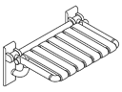

* + - * 1. Wall-Mounted Bathtub Seats: ADA-compliant fold-up seat with drainage spaces between slats; **450 lb (204 kg)** load capacity; supplied with anchorage components for cavity walls.

Size: **29-1/8 by 17 inches (740 by 432 mm)**; [**801.51US520] [or] [980.20.7xx]**.

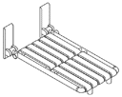

* + - * 1. Wall-mounted L-Shaped Seats: ADA-compliant fold-up seat with drainage spaces between slats; **450 lb (204 kg)** load capacity; supplied with anchorage components for cavity walls.

Configuration: Long bench on left side; **[801.51US320L] [or] [980.20.3xx]**.

Configuration: Long bench on right side; **[801.51US320R] [or] [980.20.4xx]**.

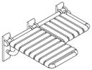Left-side model 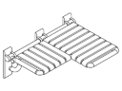Right-side model

* + - * 1. Removable Hanging Seats: Removable hanging seat with back rest that can be repositioned on a supporting grab bar (separate item); **350 lb (150 kg)** load capacity.

Seat Width: **13-9/16 inches (345 mm)**; **[801.51US100] [or] [988.76.3xx]**.

Seat Width: **17-5/5 inches (448 mm)**; **[801.51US110] [or] [988.76.4xx]**.

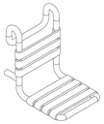

* + - * 1. Freestanding Bench Seats: Movable floor-supported shower seats; **770 lb (350 kg)** load capacity.

Length: **27-1/16 inches (688 mm)**; **[801.51US8400] [or] [988.76.3xx]**.

Length: **37-13/16 inches (960 mm)**; **[801.51US8410] [or] [988.76.3xx]**.

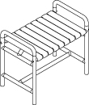 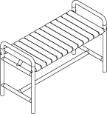

* + - 1. BATHROOM ACCESSORIES
         1. Toilet Paper Holder – Plain: Wall-mount unit; **[477.21.US100] [or] [988.80.4xx]**.

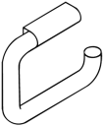

* + - * 1. Toilet Paper Holder – Antitheft: Wall-mount unit with retainer to prevent unauthorized removal of toilet paper roll; **[477.21US150] [or] [988.80.5xx]**.

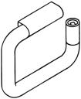

Specifier Note: The following spare toilet paper holders do not have equivalent Häfele models.

* + - * 1. Spare Toilet Paper Holder – Single Roll: Wall-mount unit with vertical rod for single toilet paper roll; 801.21US401.

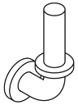

* + - * 1. Spare Toilet Paper Holder – 2-Roll: Wall-mount unit with vertical rod for 2 toilet paper rolls; 801.21US403.

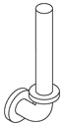

* + - * 1. Spare Toilet Paper Holder – 3-Roll: Wall-mount unit with vertical rod for 3 toilet paper rolls; 801.21US402.

S03495

* + - * 1. Holder and Tumbler: Ring-shaped wall bracket **[477.00US100] [or] [988.09.1xx]**.

Polyamide Tumbler: [**477.04US020] [or] [988.21.4xx].**

**Clear Glass Tumbler: [477.04US005] [or] [988.21.311]**.

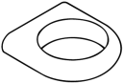 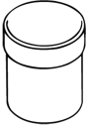

* + - * 1. Soap Dish Small: Wall-mount **3-13/16 (97 mm)** inch dish; **[477.02US100] [or] [988.05.2xx]**.

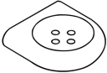

* + - * 1. Soap Dish – Large: Wall-mount **4-3/4 inch (120 mm)** dish; **[477.02US200] [or] [988.05.6xx]**.

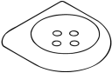

* + - * 1. Soap Dispenser: Wall-mount unit for one-hand operation; lockable container lid; **[477.06US1005] [or] [988.03.3xx]**.

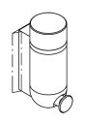

* + - * 1. Shelf: Wall-mount shelf with raised edge; **5-1/2 inches** **(140 mm)** by **23-5/8** **(600 mm)**; **[477.03US100] [or] [988.26.1xx]**.

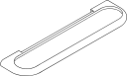

* + - * 1. Corner Shelf: Round dish with drain hole; supported by two corner or parallel arranged mounting bases for mid-wall-mounting; **[477.32US100] [or] [988.26.9xx]**.

w0037

Specifier Note: The following item does not have an equivalent Häfele model.

* + - * 1. Corner Shelf With Wall Bracket: High side walls for toiletries; chrome-plated bracket with synthetic body in **[Pure White] [or] [Biscuit] [or] [Anthricite Gray]** color; 802.03US220.

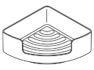

* + - * 1. Towel Ring: Rotating ring can be vertical or rotated to 30 degree detent; **[477.09US300] [or] [988.47.1xx]**.

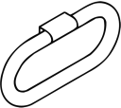

* + - * 1. Paper Towel Dispenser: Wall-mount container; 450 towel capacity; lockable; **[477.06 US6005] [or] [988.90.5xx]**.

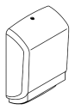

* + - * 1. Paper Towel Basket: Freestanding or wall-mount unit; perforated steel plate with polyamide top that secures waste bags.

Black Color: **[477.05US211] [or] [988.99.1xx]**

White Color: **[477.05US212] [or] [988.99.2xx]**.

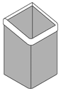

* + - * 1. Waste Bin: Wall-mount cylindrical unit with hinged lid that opens with pressure against unity by knee, arm, or hand; **[477.05US300] [or] [988.99.0xx]**.

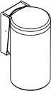

Specifier Note: The following item does not have an equivalent Häfele model.

* + - * 1. Feminine Hygiene Bag Dispenser: Wall mount unit for intake and removal of standard hygiene bags made from plastic; 477.06US750.

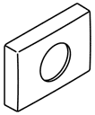

* + - * 1. Toilet Brush Unit – Wall-Mount, Round Bottom: Wall-mount holder with rotating upper portion to conceal brush head; unit can be installed to prevent unauthorized removal of brush; brush has replaceable bristle head; **[477.20US100] [or] [988.81.2xx]**.

w0046

* + - * 1. 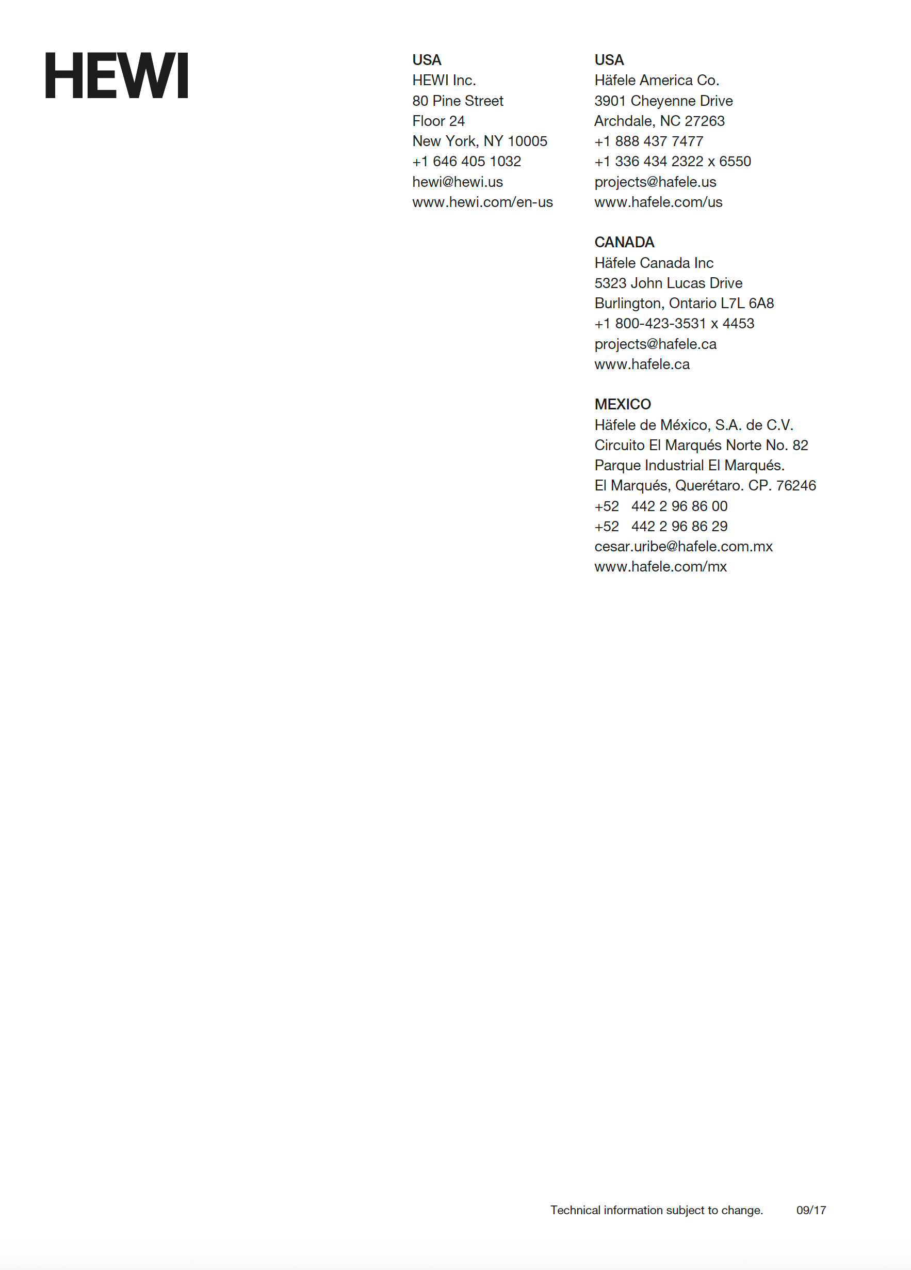Toilet Brush Unit – Wall-Mount, Conical: Wall-mount holder with tapered conical receptacle that centers brush in vertical position; reservoir for disinfectant; brush has replaceable bristle head; **[801.20US100] [or] [988.81.8xx]**.

w2219

* + - * 1. Single Robe Hook: Wall-mount unit with single hook; **[477.90US010] [or] [842.61.2xx]**.

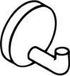

* + - * 1. Double Robe Hook: Wall-mount unit with two hooks; **[477.90US025] [or] [842.62.2xx]**.

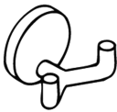

* + - * 1. Robe Hook – Extended: Wall-mount unit with single extended hook; **[477.90US030] [or] [842.61.4xx]**.

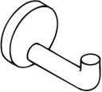

* + - * 1. Robe Hook – Door Bumper: Wall-mount unit with extended hook and resilient bumper; **[477.90US35] [or] [842.63.4xx]**.

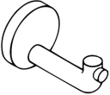

Specifier Note: The following item does not have an equivalent Häfele model.

* + - * 1. Walking Aid Holder: Wall-mount unit for holding walking aids; **[950.90US6090]**

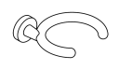

* + - * 1. Towel Bar Without Roses: **1-1/8 inch (28mm)** diameter rail.

Length: **9-13/16 inches (250 mm)** c/c; **[477.31US110] [or] [988.40.1xx]**.

Length: **18 inches (457 mm)** c/c; **[477.30US210] [or] [988.40.2xx]**.

Length: **22-7/16 inches (570 mm)** c/c; **[477.30US110] [or] [988.40.3xx]**.

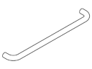

* + - * 1. Towel Bar with Roses: **1-1/8 inch (28mm)** diameter rail with rosettes at anchorages

Length: **9-13/16 inches (250 mm)** c/c; **[477.31US100] [or] [988.40.5xx]**.

Length: **18 inches (457 mm)** c/c; **[477.30US200] [or] [988.40.6xx]**.

Length: **22-7/16 inches (570 mm)** c/c; **[477.30US100] [or] [988.40.7xx]**.



* + - * 1. Shower Curtain Rail: Aluminum core with polyamide cover; right-angle configuration for wall and vertical ceiling support at corner.

Square Configuration: **36 by 36 inches (915 by 915 mm)** with 20 curtain rings; **[801.34US100] [or] [988.54.4xx]**.

Rectangular Configuration: Square Configuration: **36 by 60 inches (915 by 1524 mm)** with 24 curtain rings; **[801.34US110] [or] [988.54.5xx]**.

Ceiling Support: Adjustable for leveling; **[801.34US020] [or] [988.52.8xx]**.



* + - 1. ACCESSORIES
         1. Anchorage Fasteners: Supply units with non-corrosive anchorage screws of types recommended by unit manufacturer for Project wall types.

1. EXECUTION
   * + 1. EXAMINATION
          1. Verify correct concealed blocking and support framing is installed and located correctly.
       2. INSTALLATION
          1. Install bath accessories to meet performance requirements and comply with manufacturer instructions.
          2. Drill tile finishes to permit fastening bath accessories to structural backup.
          3. Mechanically attach bath accessories to wall framing or concealed blocking within partitions.

Use concealed anchors.

Specifier Note: Delete following subparagraph if all installations are in residential units.

Where installed in public areas, use tamper-resistant anchorages.

* + - * 1. Install bath accessories plumb and level

Mounting Heights: **[See Drawings] [or] [ICC A117.1].**

* + - * 1. Tolerances:

Maximum Variation from Position: **1/8 inch (3 mm).**

Maximum Variation from Level: **1/16 inch (1.5 mm)** over length of unit**.**

Maximum Variation from Plumb: **1/16 inch (1.5 mm)** over height of unit.

* + - 1. ADJUSTING
         1. Adjust operable units to operate smoothly to full extent of designed movement.
      2. SCHEDULE
         1. Bath Accessory Schedule: **[See Drawings.] [or] [See attachment to this Specification.]**

END OF SECTION

*Copyright © 2017 by HEWI*

