Published by | Editorial Office

HEWI
Marketing + Innovation

HEWI Heinrich Wilke GmbH
Postfach 1260
34442 Bad Arolsen
Germany
Phone: +49 5691 82-0
presse@hewi.de
www.hewi.com

Lisa Meyer-Floren
Phone: +49 5691 82-214
lmeyer-floren@hewi.de

Nicolo Martin
Phone: +49 5691 82-106
nmartin@hewi.de

Reproduction permitted, kindly provide sample copy

Accessories
System 815
The accessory line System 815, developed in collaboration with Phoenix Design, has already won several design awards, including a iF Product Design Award and the Red Dot Design Award. The design language of System 815 follows HEWI's classic design principles and is based on basic geometric shapes. System 815 impresses with a high-quality, sophisticated look and feel. The line consists of functional accessories for vanity units, toilets and showers.

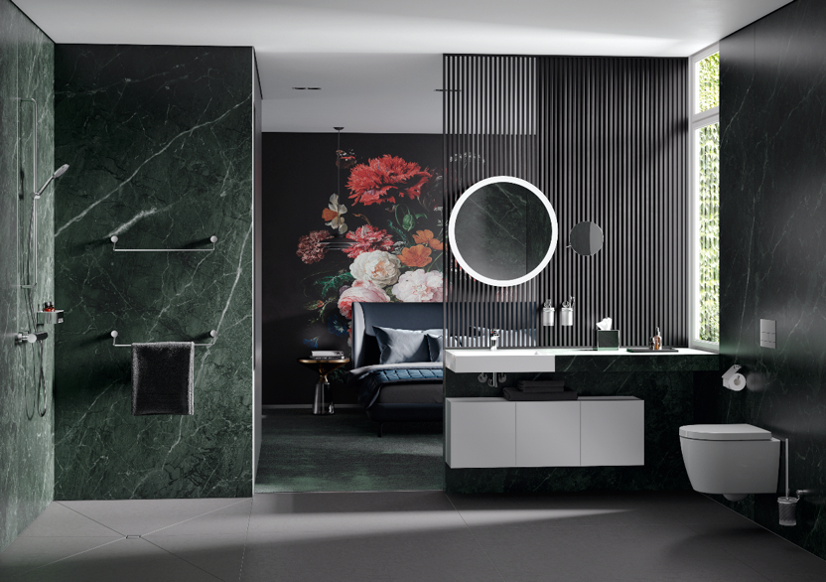
System 815: Sophisticated accessories

HEWI | Hotel

All HEWI systems are based on the design principle of reduction down to the essential. The high-quality accessories for the areas vanity unit, shower and toilet in a minimalist design perfectly integrate into any hotel bathroom.
A wide range of materials and distinctive looks offer countless design options. Besides accessories, the range also includes accessible furnishing solutions and fittings.

