Publisher | Editors

HEWI
Marketing + Innovation

HEWI Heinrich Wilke GmbH
PO Box 1260
D-34442 Bad Arolsen
Phone: +49 5691 82-0
presse@hewi.de
www.hewi.com

Clara Brenneker
Phone: +49 5691 82-214
cbrenneker@hewi.de

Nicolo Martin
Phone: +49 5691 82-106
nmartin@hewi.de

Reprint free of charge - copy requested

Accessories
System 815
The System 815 accessory line developed with Phoenix Design has already received several design awards such as the iF product design award and the red dot award. The design language of System 815 follows the principles of classic HEWI design and refers to basic geometric shapes. System 815 impresses with its high-quality, elegant appearance. Functional accessories for washbasin, WC and shower are available.

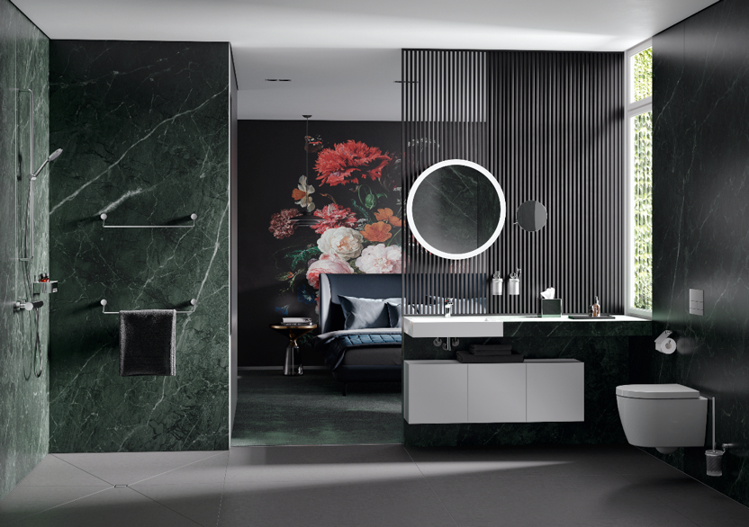
System 815: Noble accessories

HEWI | Hotel

Reduction to the essentials is the design principle that corresponds to all HEWI systems. The high-quality accessories for the washbasin, shower and WC areas in minimalist design blend perfectly into any hotel bathroom.
Diverse materials and differentiated designs offer countless design options. In addition to accessories, the range also includes solutions for barrier-free furnishing and fittings.

