Publisher | Editors

HEWI
Marketing + Innovation

HEWI Heinrich Wilke GmbH
PO Box 1260
D-34442 Bad Arolsen
Phone: +49 5691 82-0
presse@hewi.de
www.hewi.com

Clara Brenneker
Phone: +49 5691 82-214
cbrenneker@hewi.de

Nicolo Martin
Phone: +49 5691 82-106
nmartin@hewi.de

Reprint free of charge - copy requested

System 900
Powder coating
System 900 is the answer to the complex requirements of barrier-free bathrooms. The products are well thought-out down to the smallest detail - they impress with their functionality, lasting quality, clever installation technology and hygienic design. System 900 combines purist design with high functionality and a unique depth of range. With System 900, comfort can be designed.
For HEWI, good design also means offering options. System 900 enables design options thanks to the wide range of materials. With System 900 in a matt finish, HEWI provides a new, exciting source of inspiration. System 900 is available with a stainless steel or chrome surface and with powder coating in white, grey tones or black. Authentic materials and the timeless yet expressive product design give rooms character.

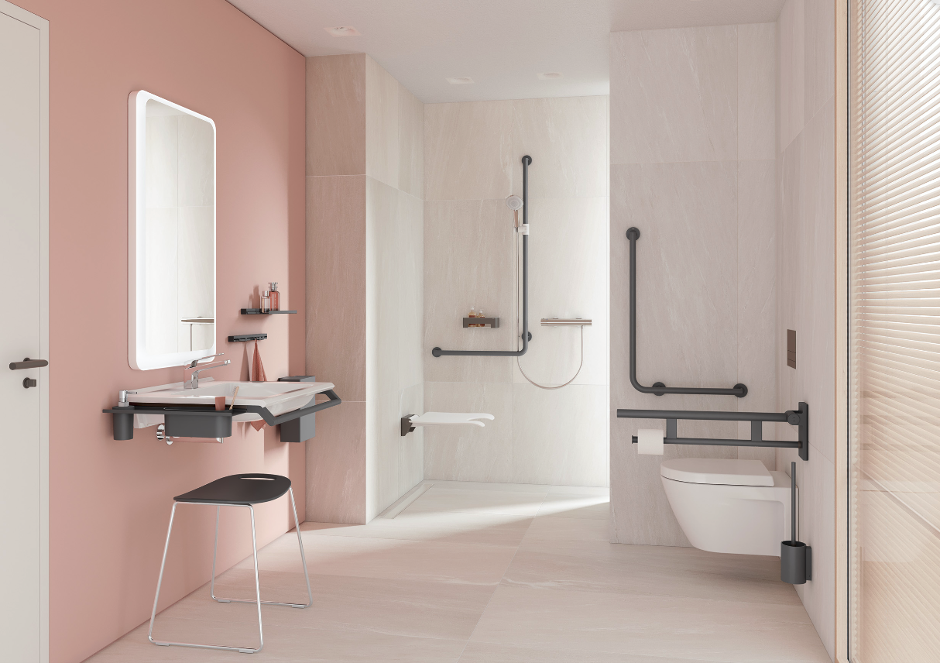
System 900 with powder coating

HEWI | Professional Care

Making people's lives easier - with individually adaptable concepts that enable independence and provide security - is what drives us. Universal Design incorporates the needs of all people. We have been living this ideal for more than 35 years as a sustainable and holistic design philosophy.
The modular principle allows individual planning - so optional service areas or comfort wards can be implemented just as easily as areas for regular patients. A well-designed bathroom contributes to the well-being of the patients and at the same time relieves the nursing staff. HEWI offers complete solutions, innovative installation concepts and support in planning and equipping barrier-free bathrooms, access points and doors in healthcare buildings.

