Published by | Editorial Office

HEWI
Marketing + Innovation

HEWI Heinrich Wilke GmbH
Postfach 1260
34442 Bad Arolsen
Germany
Phone: +49 5691 82-0
presse@hewi.de
www.hewi.com

Lisa Meyer-Floren
Phone: +49 5691 82-214
lmeyer-floren@hewi.de

Nicolo Martin
Phone: +49 5691 82-106
nmartin@hewi.de

Reproduction permitted, kindly provide sample copy

Flexible features
Modular washbasin system
HEWI's modular washbasin system is fully customisable. The unique concept allows the integration of a grab rail and a modular storage system directly by the vanity unit.
The washbasin system offers safety and ensure that all bathroom utensils are always located within easy reach. HEWI's modular washbasin system is fully customisable, easy to extend, and the additions are just as easy to remove.

Side trolley
The side trolley offers flexible storage space. It can conveniently be pushed to wherever it is needed. As a design statement, it not only looks good in the bathroom but is also a flexible storage solution for living areas. The storage shelves are generously dimensioned. The side trolley is equipped with braked castors for additional safety. The side trolley is available with a powder-coated finish in high gloss white or matt black with sophisticated chrome elements.
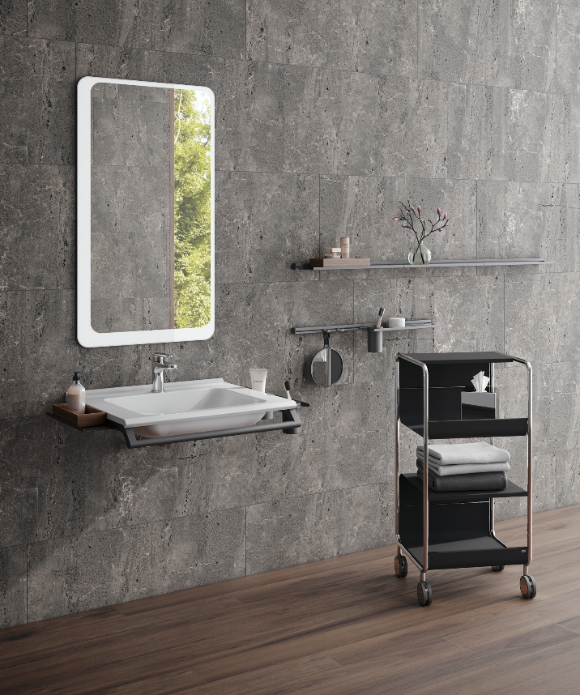

Modular washbasin system and flexibly usable side trolley

HEWI | Home

Feeling safe and comfortable in your own home is becoming increasingly important. Customisable solutions, precisely tailor-made to meet everyone's individual needs, authentic materials and a timeless, reduced product design are becoming increasingly important in bathroom design and furnishing.
HEWI system solutions offer safety and additional support. Together with their outstanding design, this creates a feel-good ambience that is a unique combination of functionality, comfort and aesthetics.

