Publisher | Editor

HEWI
Brand + Distribution

HEWI Heinrich Wilke GmbH
PO Box 1260
D-34442 Bad Arolsen
Phone: +49 5691 82-0
presse@hewi.de
www.hewi.com

Free for reprint – copy requested

Rich in contrast and individual
HEWI presents DUO: the round ceramic washbasin – an inspiration for bathrooms in the home, in hotels and in public areas.
With DUO, HEWI presents a counter-top washbasin for the first time and expands the product range with a solution that picks up on current bathroom trends and plays with colour and finish.

As a consistent supplement to wheelchair-accessible models, modular washbasins, compact versions for the small guest bathroom and variable-length designs, DUO can be flexibly positioned on console tables or furniture base units, creating new free space in bathroom architecture.

High-quality ceramics
DUO also provides fresh impetus in terms of materiality: the washbasin is made of high-quality ceramic, a traditional yet contemporary material that combines craftsmanship with modern functionality. The inside is always glossy white, while the outside can be finished in either glossy white, glossy grey or matt black. This creates strong visual contrasts or, in the pure white version, a clean, classic look.

Hygiene and comfort
The product is designed without an overflow, which makes it particularly hygienic. Areas that are difficult to clean, where bacterial growth or dirt accumulation can occur, are thus reduced to a minimum. With a height of 15 cm, a diameter of 42.6 cm and an internal basin depth of 12 cm, the model is compact and at the same time offers plenty of comfort and convenience when washing. A total of two variants of the new model are available: Counter-top washbasin with and without tap hole.

As a system provider, HEWI offers the entire sanitary fit-out from a single source. The tried-and-tested fittings and accessories integrate seamlessly into the style of the DUO washbasin and contribute to the clear lines of the bathroom.
Captions:
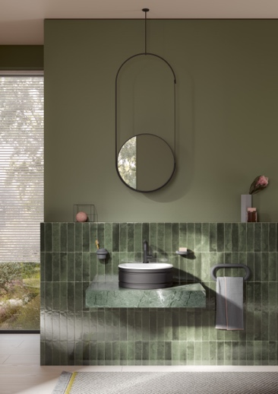
1 Elegant in design, clear in concept: The DUO washbasin from HEWI gets to the heart of modern bathroom design. Image: HEWI
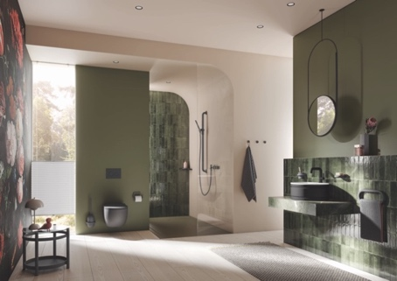
2 The new DUO washbasin from HEWI offers classic elegance and contrasting two-tone colours, thus enabling versatile design options for stylish bathrooms. Image: HEWI

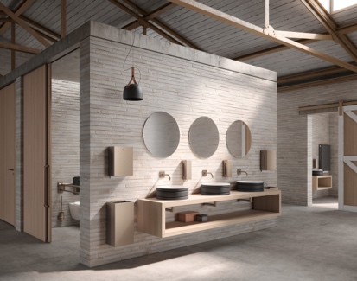
3 Made from high-quality ceramic, the DUO washbasin from HEWI is suitable for use in public areas – easy-care, durable and functional. Image: HEWI

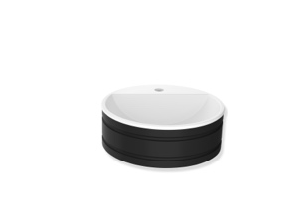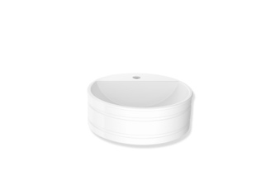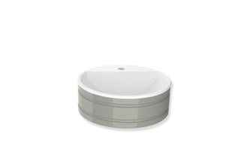
4 Individual selection: The outside of the DUO washbasin is available in a choice of glossy white, glossy grey or matt black – the inside is always glossy white. Image: HEWI

