Publisher | Editors

HEWI
Marketing + Innovation

HEWI Heinrich Wilke GmbH
PO Box 1260
D-34442 Bad Arolsen
Phone: +49 5691 82-0
presse@hewi.de
www.hewi.com

Reprint free of charge - copy requested

mini
Reduction to the essentials
With mini, HEWI redefines the term minimalism. The innovative technology enables a minimalist rose that reduces the door handle to the essentials and at the same time sets the scene in a completely new way.
mini convinces with a particularly simple installation. The patented concept allows the rosette to be fixed without drilling. The mini rosette is permanently connected to the door by an innovative press-in bearing. The new hardware solution can be combined with all commercially available locks.
With mini, there is a new interplay between hardware and door - both for interior and residential doors in private homes or apartment buildings as well as in office and commercial buildings.
As of July 2017, mini can be combined with selected HEWI lever handles made of stainless steel or polyamide.

Design: HEWI, Bad Arolsen

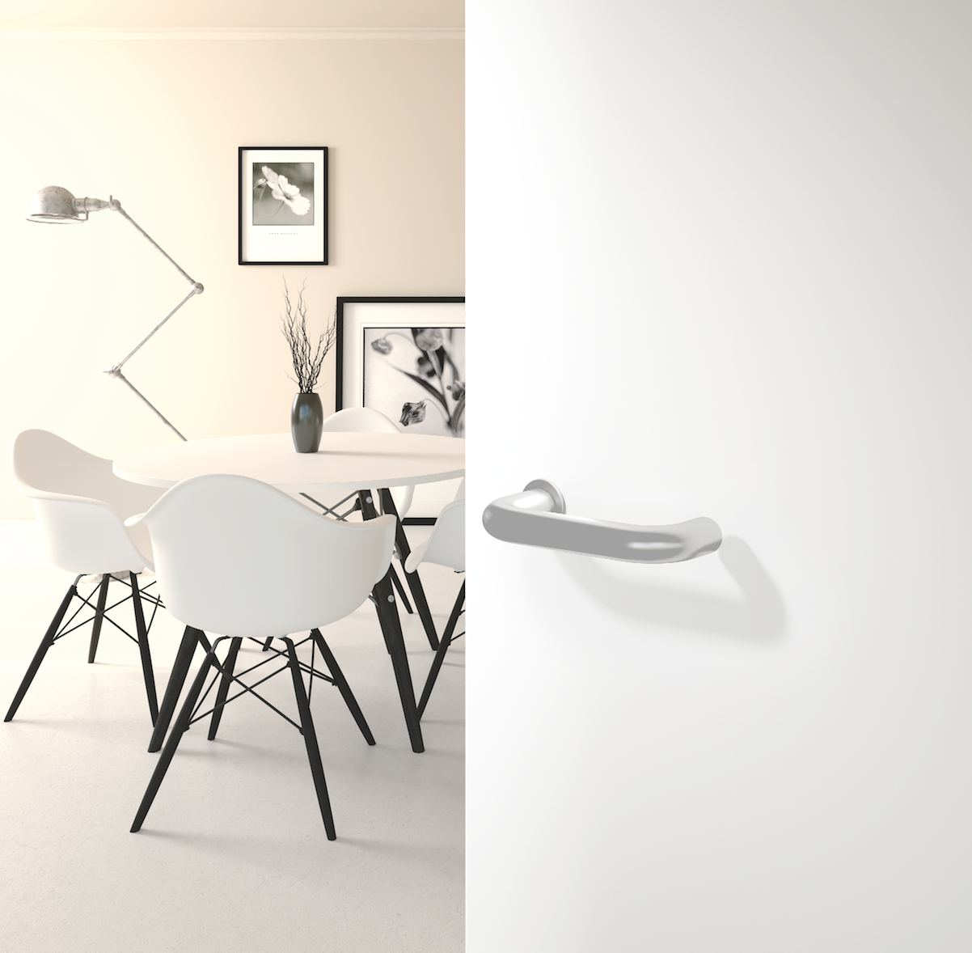

The fitting is given a whole new look with mini.

For more information, please contact:

HEWI Heinrich Wilke GmbH
PO Box 12 60
D-34442 Bad Arolsen
Phone +49 5691 82-0
Email: presse@hewi.de
Internet: www.hewi.com

