Publisher | Editors

HEWI
Marketing + Innovation

HEWI Heinrich Wilke GmbH
PO Box 1260
D-34442 Bad Arolsen
Phone: +49 5691 82-0
presse@hewi.de
www.hewi.com

Clara Brenneker
Phone: +49 5691 82-214
cbrenneker@hewi.de

Nicolo Martin
Phone: +49 5691 82-106
nmartin@hewi.de

Reprint free of charge - copy requested

Mobile solutions for the hotel bathroom
Shower seats and folding support handles

The rooms of a hotel should be as individual as the guests. HEWI offers the possibility of flexibly adapting the bathrooms to the needs of the guests. If a guest requires support, the mobile shower seats and folding support rails can be quickly and easily integrated into the respective room. The proven fixing technology is easy to use and requires no tools.
Cleaning staff can add and remove the mobile folding support handles and shower seats quickly and easily.

When they are no longer needed, a discreet cover cap conceals the permanently installed mounting plate. This way, hoteliers can increase their occupancy rate by providing barrier-free rooms to all guests without them even noticing. The mobile solutions offer the same functionality as permanently installed folding support rails and shower seats.

Of course, the mobile solutions also offer maximum flexibility in the area of professional care and at home. Mobile shower seats and folding support rails are available in various designs and versions, enabling optimal solutions for all requirements.

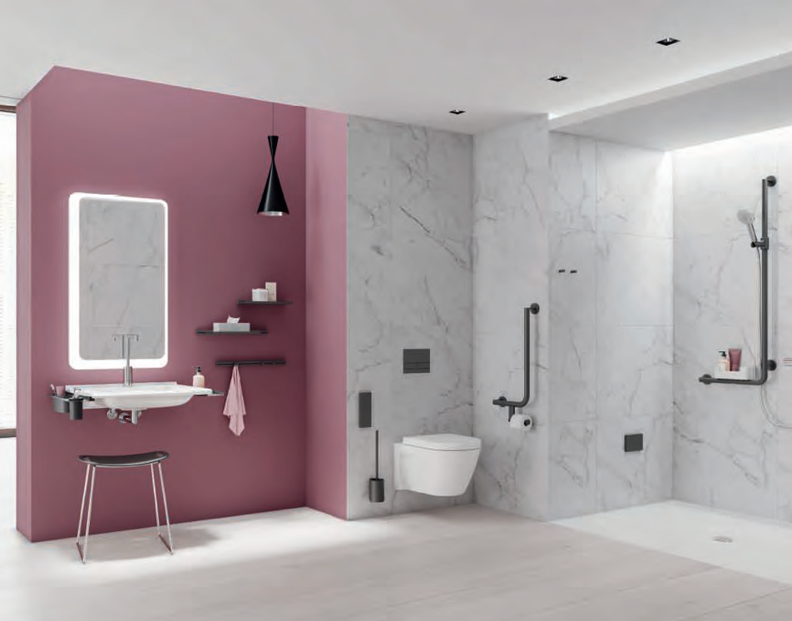

Before: Discreet cover caps conceal the permanently installed mounting plates

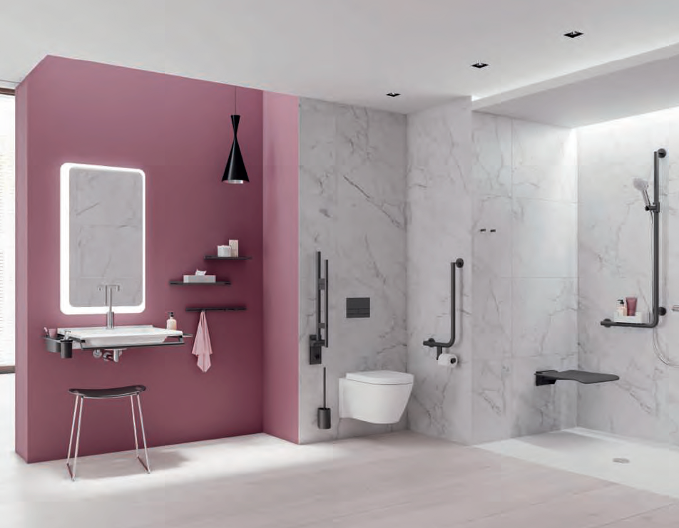

After: The mobile solutions can be integrated quickly and easily in the bathroom.

