Published by | Editor

HEWI
Marketing + Innovation

HEWI Heinrich Wilke GmbH
P.O. box 1260
D-34442 Bad Arolsen
Telephone: +49 5691 82-0
presse@hewi.de
www.hewi.com

Lisa Meyer-Floren
Phone: +49 5691 82-214
lmeyer-floren@hewi.de

Nicolo Martin
Phone: +49 5691 82-106
nmartin@hewi.de

Reprint free - specimen copy requested

HEWI Kids
Child-friendly equipment
HEWI products for children are tailor-made to the needs of their small users - whether in child daycare centres, kindergartens or schools. Rooms for children must be designed to be practical, easy care and safe. HEWI has developed products that optimally fulfil these requirements and also offer diverse child-friendly and individual design options.
HEWI Kids comprises Splash it – the solutions around the washing area, Hang it – the colourful, classic wardrobe systems and Drop it – the new, very clever storage system.

New: Drop it
The new Drop it Kids furniture opens up space for design variety. Due to its modular nature, it is highly flexible and fits into almost every kindergarden or primary school hallway. The single cube forms the central design element and can be expanded individually.
The various modules (single, series or dual modules) can be arranged and combined at will to suit requirements. They create the possibility for completely new, asymmetrical solutions.
Triple hooks ensure order and set colourful accents in the wardrobe area. Ergonomic benches in various heights complement the furniture and thereby blend harmoniously into the design of the nursery and primary school. The new furniture system is therefore suitable for small and large users.
Products used in kindergardens or schools must be able to withstand frequent use permanently. The high-quality modules are manufactured from birch multiplex and refined with white decoration finishes. The material is very durable and easy to look after. The products are designed in a lightweight and reduced design so that the risk of injury is largely excluded. They have been tested in the line with the stricter requirements for kindergardens or schools according to the valid GS guidelines (tested safety).

HEWI Kids Splash it & Hang it
We have always focused on safety during the development of the HEWI products for children. The fine radii of the washbasins means there are no corners or edges created on which children could bruise themselves. The narrow edge as well as compact design of the mineral cast washbasins allow even small children to reach the easy to operate fittings effortlessly.
The mirrors made of ESG safety glass are equipped with a shatterproof film as well as a safety mounting catch. The washbasins and mirrors are optionally available in classic white or as a two-coloured version with a contrast in cheerful apple green. The coloured, customisable toothbrush cup strips are an eye-catcher, irrespective of whether at home, in kindergarden or in the day care centre..
They can be extended as preferred via an extension module for four additional spaces. The toothbrush cup strips are available with towel hooks as an option.
Design: HEWI

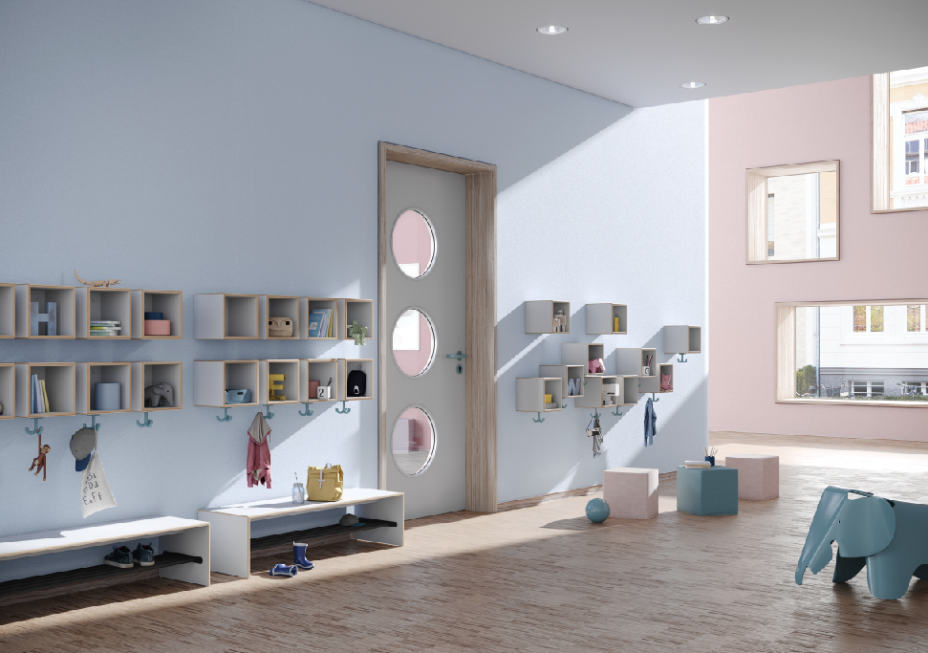
HEWI Kids | Drop it enables individual furnishing for kindergarden or primary school hallways.

