Publisher | Editors

HEWI
Marketing + Innovation

HEWI Heinrich Wilke GmbH
PO Box 1260
D-34442 Bad Arolsen
Phone: +49 5691 82-0
presse@hewi.de
www.hewi.com

Reprint free of charge - copy requested

New HEWI website
Inspiration and information

With immediate effect, HEWI's new website at www.hewi.com offers you even more inspiration, solution-oriented information for your individual property requirements and improved opportunities to contact the accessibility expert directly.
In the Professional Care, Public, Hotel, Education and Home application areas, discover planning and furnishing recommendations for all types of property - whether hospitals, public buildings, schools or your own four walls.
The intuitive structure makes it easier for you to find suitable product solutions in the areas of sanitary and fittings.
With the new online magazine HEWI Mag, HEWI gives you exciting insights into the HEWI company and its expertise with interviews, design stories and references:
Design. Comfort. Care.

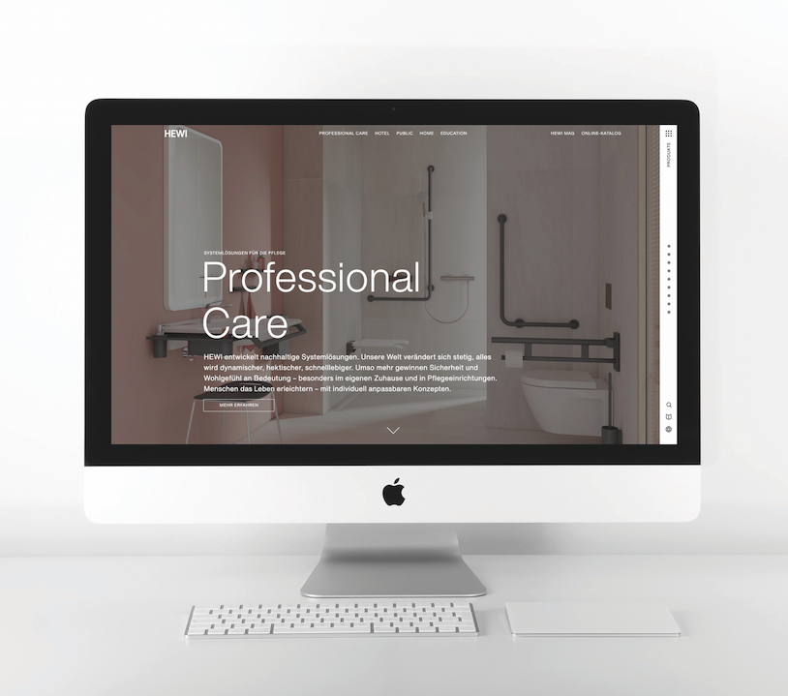
New HEWI website convinces with inspiration possibilities and intuitive structure

