Publisher | Editors

HEWI
Marketing + Innovation

HEWI Heinrich Wilke GmbH
PO Box 1260
D-34442 Bad Arolsen
Phone: +49 5691 82-0
presse@hewi.de
www.hewi.com

Clara Brenneker
Phone: +49 5691 82-214
cbrenneker@hewi.de

Nicolo Martin
Phone: +49 5691 82-106
nmartin@hewi.de

Reprint free of charge - copy requested

Successful market launch
System 900
The new 900 sanitary system has had a particularly successful market launch.
After just one year, it is clear: System 900 is convincing customers in a wide range of application areas and property types. Numerous awards prove that System 900 is the answer to the complex requirements of barrier-free bathrooms.
The products are well thought-out down to the smallest detail: they impress with their functionality, lasting quality, clever installation technology and hygienic design. System 900 meets the requirements of a wide variety of building types - whether in the regular patient bathroom of a hospital, in the comfort ward of a private clinic, in a nursing home or in an exclusive retirement home. With a focus on people, System 900 supports users and carers alike.
In the hotel, too, System 900 combines aesthetics with clever functions for more comfort in the bathroom. Material options allow freedom of design - System 900 is available with stainless steel, chrome and powder-coated surfaces in various shades. Deep matt white, light grey pearl mica, dark grey pearl mica and black offer design options.
Multiple awards
HEWI has already been successful in five competitions with System 900 and has been awarded renowned prizes. The juries particularly emphasised the high design standards of barrier-free product solutions, coupled with clever functions and customised solutions, which make the system unique on the market.
iF Gold Award 2019
HEWI takes gold. System 900 was able to convince the jury of experts and was awarded the coveted design prize. 67 jury members evaluated the best design achievements from more than 50 countries. For 65 years, the iF Design Award has been a globally recognised trademark when it comes to excellent design. The iF Design Award is one of the most important design prizes internationally.
Universal Design Award 2019
HEWI was awarded the Universal Design Award "consumer favorite" and the Universal Design Award "expert favorite" for System 900 and was thus able to convince both the end user and the expert jury. The award honors outstanding products that are trend-setting and can be used across generations. The prize is awarded by the Institute for Universal Design. The Institute for Universal Design has set itself the task of linking business, science and society in a socially responsible context.
German Design Award 2019
System 900 was awarded the "German Design Award - Winner 2019" in the category "Bath and Wellness". The German Design Award discovers and presents unique design trends: a competition that promotes the design-oriented economy.
The competition is organised by the German Design Council. This is one of the leading international centres of excellence for design.
ZVSHK Award 2019
At the world's leading trade fair for sanitary technology, the ISH in Frankfurt, the German Sanitation, Heating and Air Conditioning Association (Zentralverband Sanitär Heizung Klima - ZVSHK) selected the winners of the "Bathroom Comfort for Generations" product competition for the fourth time.
"The modular design of System 900 allows versatile combination options to optimally meet user needs and architecture. The clever installation technology is convincing: a new type of plug-in snap-in connection allows installation with fewer fastening points and the concealed fastening stands for hygiene and good design," the jury said in explaining its decision.

Iconic Awards 2018
System 900 was awarded the Iconic Award 2018 "Innovative Architecture". With this competition, the German Design Council honours the icons of the architectural world in 2018. Awards are given to visionary buildings, innovative products and sustainable communication from the categories of architecture, construction and industry.
lazienka wybor roku 2019
In addition to building regulations and standards for accessibility, the individual needs and abilities of the respective user must also be taken into account. System 900 meets these requirements and also convinces in international competition. System 900 received the Polish award "lazienka wybor roku 2019".
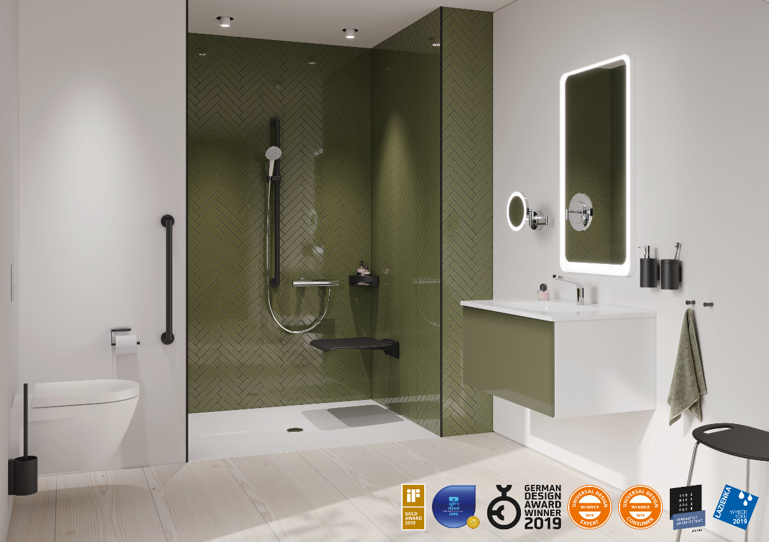
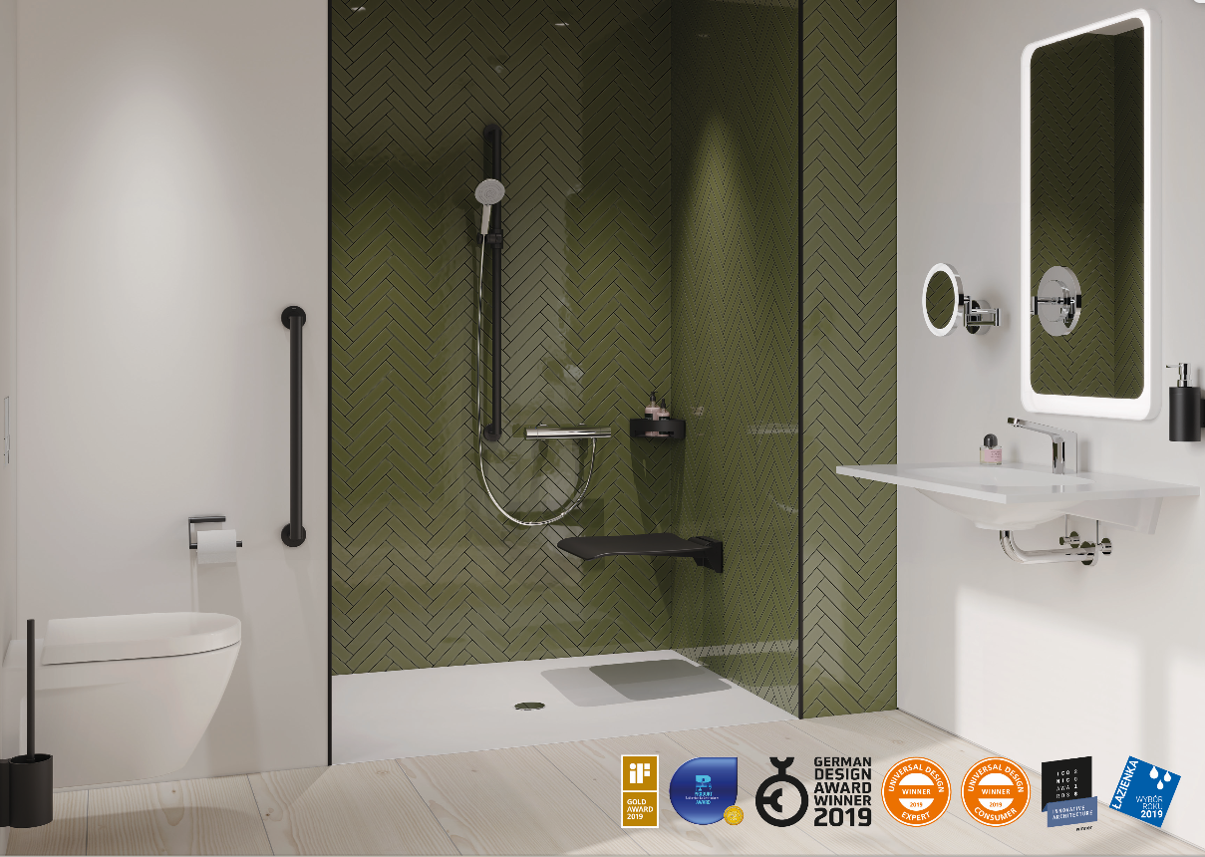
Images: System 900 can be used to design comfort bathrooms with clever functions as well as low-barrier bathrooms and standard-compliant solutions.

