Subscribe to DeepL Pro to edit this document.
Visit www.DeepL.com/profor more information.
Publisher | Editors

HEWI
Marketing + Innovation

HEWI Heinrich Wilke GmbH
PO Box 1260
D-34442 Bad Arolsen
Phone: +49 5691 82-0
presse@hewi.de
www.hewi.com

Reprint free of charge - copy requested

System fittings

HEWI system design
The HEWI system design allows a uniquely consistent design from the entrance door to the sanitary room. HEWI system fittings follow this principle and complement the existing portfolio. They form a design unit with the HEWI sanitary accessories, barrier-free products, washbasins and fittings. HEWI System fittings perfectly complement the HEWI sanitary systems so that the sanitary room can be consistently designed in one design.
Two forms of operation - one design language
Tested, high-quality materials not only offer safety, but also guarantee the longevity of the fittings. Depending on the requirements, the mixer is available as a manually operated single-lever washbasin mixer or as a sensor-controlled mixer. Functionality and forms of operation differ in these two variants - but not in their design language.

Durable quality
Selected, first-class materials enable durable fittings and also offer safety for drinking water quality. Sophisticated technology and the exclusive use of high-quality components create the conditions for lasting reliability. The exterior of the taps is robustly designed so that even continuous use in highly frequented public sanitary rooms cannot harm them. This means that they are designed for performance and can withstand even heavy use. The use of proven components from renowned manufacturers such as Kerox or Neoperl forms the basis for reliable technology.

Proven reliability
DVGW certification and compliance with the criteria of DIN 15091 document that HEWI system fittings meet the highest quality standards. This confirms the fulfilment of demanding requirements in terms of safety, hygiene and functionality by an independent testing institute. The WELL efficiency label shows how resource-saving the system fittings are. HEWI system fittings save water and energy.

Design: HEWI, Bad Arolsen

Awards: iF DESIGN AWARD 2017

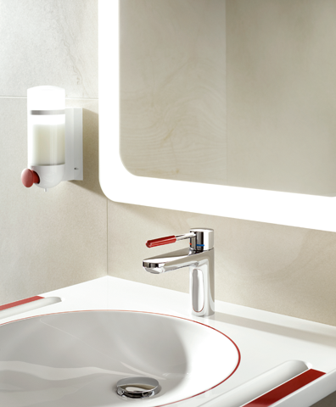
System fitting AQ 800 K Single-lever washbasin mixer with handle element in ruby red polyamide

For more information, please contact:

HEWI Heinrich Wilke GmbH
PO Box 12 60
D-34442 Bad Arolsen
Phone +49 5691 82-0
E-mail: presse@hewi.de
Internet: www.hewi.com

